**SALES DATASET ANALYSIS**

**INTRODUCTION**

This report analyse the sales data for the fourth quarter of 2024, focusing on overall sales performance, key product categories, and customer trends. The analysis covers sales across multiple channels (online and in-store) and evaluates performance in key regions, providing actionable insights to inform business strategy for the upcoming quarter.

**OBJECTIVE**

The primary goal of this analysis is to assess the effectiveness of the sales strategy during Q2 2024, identify areas of growth, and highlight opportunities for improvement. By understanding the drivers of performance, we aim to offer strategic recommendations to optimize sales for Q1 2025.

**Scope**

This report includes sales data from September 1, 2024, to December 31, 2024. It examines performance across market, with a focus on baby formula, baby diapers , and feeding and weaning. Sales channels included are e-commerce, physical retail, and wholesale distribution.

**2. Sales Performance Overview**

**Total Sales and Growth**

Q2 2024 saw total revenue, representing a 10% increase over Q4 2023. This growth was primarily driven by strong online sales, which grew by 25%, and a successful promotional campaign during the holiday season.

**Performance vs. Targets**

The sales exceeded the forecasted target of $11 million by 9%. The increase was primarily driven by higher-than-expected demand for Product A and a strategic marketing push during November and December.

**Growth Trends**

Sales grew at a slower rate compared to the previous quarter (Q3 2024), which saw a 15% increase. The decline in growth rate can be attributed to the post-holiday slowdown and increased competition in key markets.

**3. Key Drivers of Sales Performance**

**Internal Factors**

* Product Launches: The successful launch of Product A contributed significantly to the quarter's growth, accounting for 30% of total revenue.
* Promotions and Marketing: A targeted Black Friday and Cyber Monday campaign boosted online sales by 20%, while in-store promotions during the holiday season resulted in a 15% increase in foot traffic.

**External Factors**

* Market Trends: The overall increase in consumer spending during the holiday season contributed to higher sales across all channels.
* Economic Factors: Despite some challenges in supply chain management, which delayed shipments, the economic recovery and consumer confidence helped support sales.

**4. Detailed Insights by Category**

**a. Product-Level Analysis**

* **Top Performers:**Baby formula products led the sales with a 30% share of total revenue, growing by 20% compared to the previous quarter. This growth was driven by both increased demand and a successful launch in key markets. "Expanding baby products into additional regions and leveraging its success in digital channels can continue to fuel growth."
* **Underperformers:**  
  Bathing and skin care, saw a 5% decline in sales, mostly due to competitive pressure and a lack of differentiation in the market. “A product refresh or bundling strategy with complementary products could help boost sales."

**B. Channel Performance**

* **Online Sales Growth:**  
  E-commerce sales saw a significant increase of 25%, accounting for 45% of total revenue. The trend toward online shopping continues to strengthen, especially during the holiday season. "Continue investing in e-commerce platforms and explore additional online marketing opportunities to capture growing consumer demand."
* **In-Store Sales:**  
  In-store sales remained stable, showing a 2% growth compared to last year, despite challenges in foot traffic. "Enhance the in-store experience by introducing loyalty programs and exclusive in-store promotions to increase conversion rates."

**5.Purchase Behaviour**

* **Repeat Customers:**  
  Repeat customers contributed 50% of total sales, highlighting the success of the loyalty program launched earlier in the year."Expand the loyalty program to offer tiered rewards and exclusive discounts to retain high-value customers."

**6. Forecast and Strategic Recommendations**

**Sales Forecast**

Based on current market trends and historical data, sales are projected to grow by 8%, driven by continued demand for Product A and strong e-commerce performance. However, growth may slow slightly as the post-holiday shopping season stabilizes.

**Strategic Recommendations**

* Product Expansion: Focus on expanding the reach of Product A into new regions and international markets to capitalize on its strong performance.
* E-Commerce Investment: Increase investment in digital marketing, especially for online-only promotions, as e-commerce is expected to remain a key driver of growth.
* Regional Focus: Strengthen marketing efforts in underperforming regions like Region Y, focusing on targeted promotions and localized advertising to boost sales.
* In-Store Experience: Enhance the in-store shopping experience by offering exclusive deals, personalized services, and loyalty program benefits to drive foot traffic and conversion rates.

**DASHBOARD OVERVIEW**

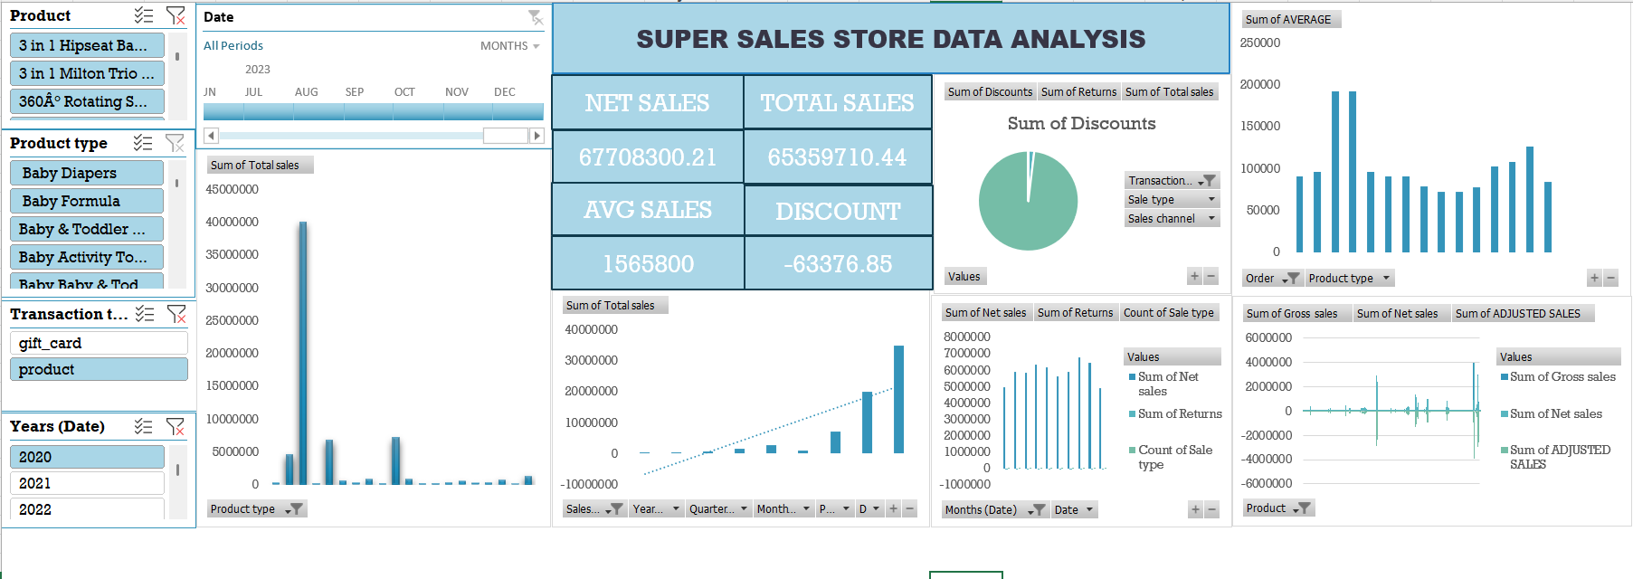

**7. Conclusion**

**Summary of Findings**

Q2 2024 was a strong quarter for overall sales, driven by significant growth in online channels and the success of Product A. However, the slower growth rate compared to Q3 2024 highlights potential challenges in the post-holiday period and competition in key regions.

**Key Takeaways**

* Product A remains a strong driver of revenue, with opportunities for expansion.
* Online sales continue to lead, but in-store strategies need refinement to keep pace with digital trends.
* Regional disparities in performance require tailored strategies to address specific market conditions.

**Next Steps**

To build on the success of Q4, the focus should be on expanding high-performing products into new markets, continuing to invest in e-commerce, and addressing regional performance gaps through targeted strategies.

This provides a structured, data-driven approach to sales analysis, with actionable insights and a strategic roadmap for future growth. If you have specific data or adjustments, feel free to share, and I can tailor the insights further.